Grace, can you add in information that you might have on
Jack Magarey birth of child
Ben Trewartha and Jessie wedding
Add in to Billy’s Corner thanks

BULLDOG BULLETIN AUGUST 2022

After 17 games of the SGL minor round South Augusta A Grade have finished in third position and will launch its campaign to win its 6th Premiership in 7 years. South Augusta A Grade have now played off in the finals for 9 years in a row and under Coach Boles have finished in the top 3 for the last 7 years. What better motivation to become the most successful club in the history of the SGL by winning our 14th SGL Premiership and surpassing Ports.
We now need all supporters and members to get behind the team, get out on the mound and support the Under 18s , B and A Grade when they play their final games. We need loud voices and cheering so please get out there and support the team.

The B Grade finished in second position and a good chance of playing in the Grand Final and the Under 18’s finished in third position. The finals have started for the Magpies Netball team so get out there and support them as well.

Great news to see Connor Rozee make the All-Australian team and it’s safe to say this is the first time this has happened to a South Augusta junior player, congratulations Connor from all the club.
Well done to the organisers of the Family Day on the Sunday 7th August and good luck to the junior grades in their quest for Premierships.

FOOTBALL OPERATIONS REPORT

A good last month for the A Grade , however the loss to Props/ Lions cost them a top 2 chance and they ended the season on 12 wins, 4 losses and 1 draw to be in third position.

Congratulations to Cam Tiggeman, Kriston Thompson, Caleb Ritter, Stefan Horner and Billy Jo Russell who made the SGL team of the team in a great achievement for their hard work and dedication over the past season.

Best players in the last 5 games are the following:

Game
13 Kriston Thompson, Kahran McKenzie, Caleb Ritter, Patrick Kennedy, Trent Ritter
14 Cameron Tiggemann, Aziel Stuart, Paul Glass, Clayton Milera, Kareem Aitken
15 Kriston Thompson, Paul Glass, Caleb Ritter, Billy-Jo Russell, Stefan Horner
16 Cameron Tiggemann, Kriston Thompson, Caleb Ritter, Aziel Stuart, Trent Ritter
17 Kriston Thompson, Paul Glass, Aziel Stuart, Kahran McKenzie, Billy-Jo Russell

Best players in the last month indicate that Kriston Thompson continues his good form and has he has proven in past finals campaigns he will be there when required. Trent Ritter, Paul Glass and Cam Tiggeman have all had good months together with Caleb Ritter and Aziel Stuart. They will all have to be at their best to challenge the teams from Pirie and we have beaten these teams this year when our game is on.

In the Madigan Medal Corey Davey from Sollies won that award with 22 votes and Kriston Thompson had 16 votes to finish 5th in the voting. Next best for Souths were Darcy Kildea and Aziel Stuart with 8 votes.

In the B Grade the best players for the last 3 weeks are:

Game
15 Connor McMillan, Jack Magarey, Tyson Darley, Robert Brown, Micheal Collins
16 Declan Franks, Dominique Stuart, Connor McMillan, Jack Magarey, Shaun Kemp
17 Declan Franks, Tyrone Waye, Jack Magarey, Connor McMillan, Byron Taylor

Another good year for the seconds after not making the finals last year. Adam Grantham and Mark Horner will have the team ready for the finals so you never know how far they will go if they can get a good team on the field and all players are available. A good month for Declan Franks, Jack Magarey and Connor McMillan and great to see Byron Taylor back on the field after a rest due to injury.

In the Dyason Medal for the B Grade Connor McMillan finished 6th with 10 votes, Shaun Kemp was next best with 9 votes. Matthew White from Props/ Lions and Scott McIntyre tied on 15 votes to be winners.

2022 Semi-Finals this week
Pt Pirie Saturday 3rd League (QF) Solomontown v PropRisdon
Seconds (QF) Solomontown v South Augusta
Under 18s (QF) Central Augusta V Port
Under 15s (EF) Port v West Augusta

Pt Augusta Sunday 4th
League (EF) South Augusta v Port
Seconds (EF) Central Augusta v PropRisdon
Under 18s (EF) West Augusta v South Augusta
Under 15s (QF) South Augusta v Central Augusta

In the junior grades we move towards the finals and at this stage the standings are:

Under 18s 3rd position, they will play off in the elimination final against West Augusta this week
Under 15’s Finished in 3rd position, will play Central in the first final
Under 13s Won their Preliminary final last week and will play Central in the Grand Final on Friday 2nd September, get along to support them.
Under 11s 3rd position at the end of the year and are now finished
Under 9s: Finished on top of the ladder at the end of the year

Under 17s girls: Went down to Central Augusta in the Grand Final, great effort for the first year of the competition.
Under 14 girls 3rd position at the end of the year

JUNIOR MEDAL RESULTS

In the Under 18s Bishop Medal Heath Green finished 2nd with 15 votes, 3 votes away from the winner Terrelle McKenzie. Jakeem Cox finished on 7 votes.

In the Nobbs Medal for the Under 15s Baylin Crouch from Port won the medal. Best for South was Ronan Coombe with 15 votes, 11 votes from the leader in 5th spot. Next best for South was Nate Munzer with 10 votes.

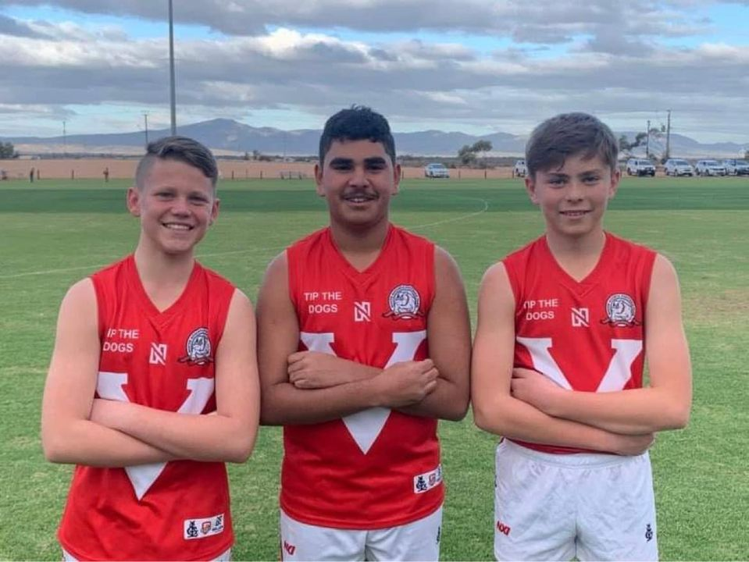

COREY MEDAL 2022
Congratulations to Addyson Di Paolo (left) who was the winner of the U13 Corey Medal on 18 votes. Zechariah Amos (middle) and Leo McInnis (right) came second with 17 votes.
Leo also won the leading goal kicker.
This is a great achievement by the boys and we look forward to watching where their footy takes them in the future.

CONNOR ROZEE MAKES ALL AUSTRALIAN TEAM

It’s been a big week for ex South Augusta junior colt Connor Rozee, winning the Showdown Medal, recognised with selection in the AFL Players' Association 2022 under 22 squad of 40 players and selection in the All Australian Squad and team.
Connor also finished top five in the Coaches award and he essentially picked himself in the All Australian team. Connor was the only South Australian in the final squad. Congratulations Connor and it’s a good example of what can be achieved with hard work and dedication even if you come from the country leagues.

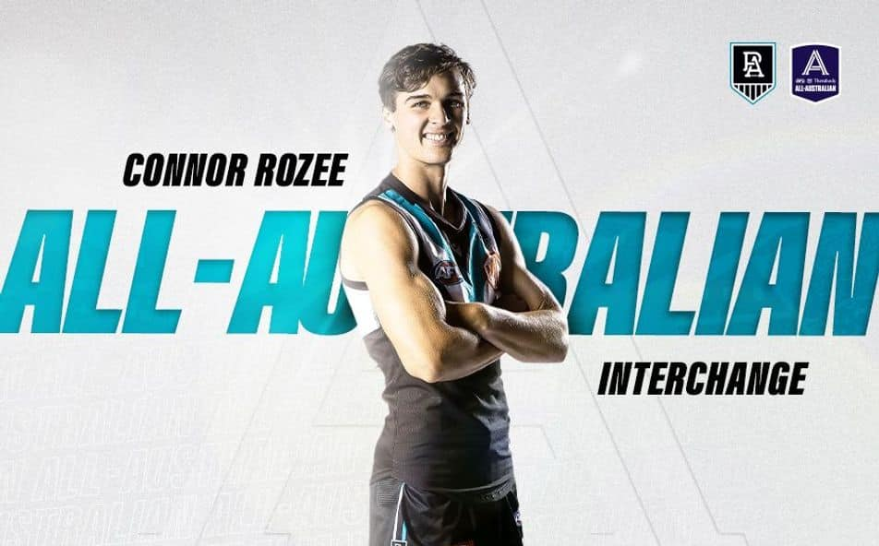
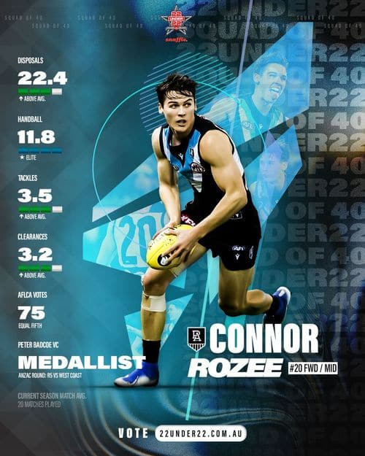

SPONSORS UPDATE
Great to another couple of sponsors come on board in the last month. Port Adelaide Football club donated a signed guernsey from Ollie Wines which we were able to auction and get $350 so that makes them a Silver Sponsor.
Scott Kennedy who was on the South Football Committee in 1993 to 1996 and served 2 years as Secretary has come on board as a Vice President Sponsor. Scott was a school teacher when in Port Augusta but ended up working for United Nations Peacekeeping in Ivory Coast and Mali. He is now retired after an interesting career and misses Port Augusta, we hope to get him back at the club one day. Many thanks Scott and Port Adelaide, through the Stephen Shirley connection.

MAGPIES NETBALL UPDATE
The Magpies Netball team, who were formed in 1957, have a great affiliation with South Augusta Football Club and the finals have started.

Results so far in the first 6 grades in the finals are as follows:
A Grade- Won by defeating St Josephs 54 to 37 pts and will play the Preliminary Final against Vikings this weekend.
B Grade- Lost to Vikings 46 to 57 pts and have been eliminated from the finals
C Grade- Lost to St Joseph’s 42 to 55 pts and now play St Joseph’s Blue in the Preliminary for a chance to go into the Grand Final .
D Grade – Lost to St Joseph’s 42 to 73 pts and will play Magpies Rebels in the Prelim this week
E Grade – Defeated Magpies Rebels 46 to 45 in a close one and will play off in the Grand Final
F Grade- Defeated Vikings 53/52 and will play off in the Preliminary Final this weekend against St Josephs.

According to the South Augusta Auction results A Grade players who have been doing well in the last few weeks in A Grade include Sophie Warren, Nicole Sulley Beales, Aysha Zada, Shaniqwa Stuart and Ellie Packard so we hope they continue that good form into the finals

All the best to all the other grades including the juniors for the remaining finals and get along and support them in their quest for Premierships. Junior Presentations are on the 13th September and Senior Presentations are on the 23rd September with the Grand Finals on the 10th September.

Support Magpies Netball Club by buying tickets in the Netball SA Community Lottery. Magpies Netball Club will raise much-needed funds, and you'll go into the draw to win some amazing prizes.
https://netballsa.raffletix.com.au/magpiesnetball

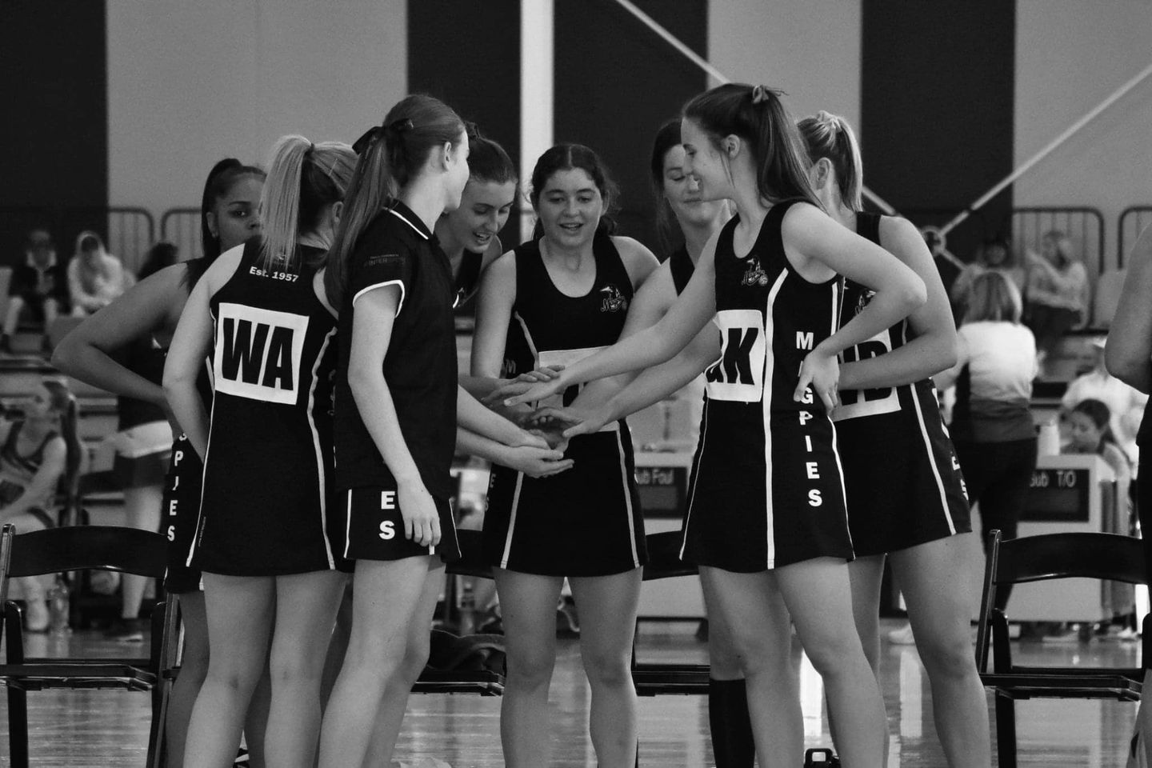

WHERE ARE THEY NOW
In the last edition of the Bulldog Bulletin we mentioned that Jenny Fulgrabe who was an ex-trainer at the club in the 1980’s is still looking after past player Mick Corey 40 years later when she was his nurse in Adelaide when he had a hip operation. Good news is that Mick is on the road to recovery and pictured here with Jenny in current times.
The other picture is on Andrew Mooney and Peter Fox both players for South in the 1980s as well and some A and B grade Premierships between them who happened to meet up in Darwin by chance, believe it or not in a Darwin Gym. By the looks as of the photo we are not that sure of this but they seem to be having a great time on their retirement travels.

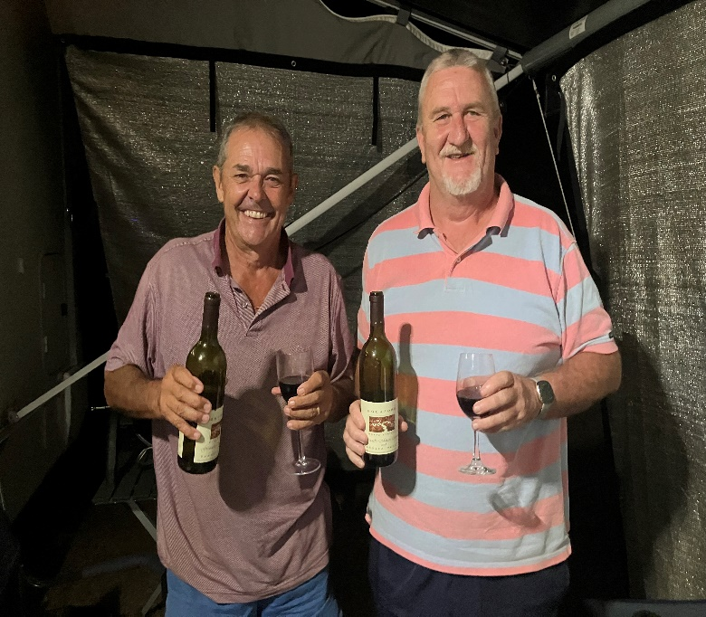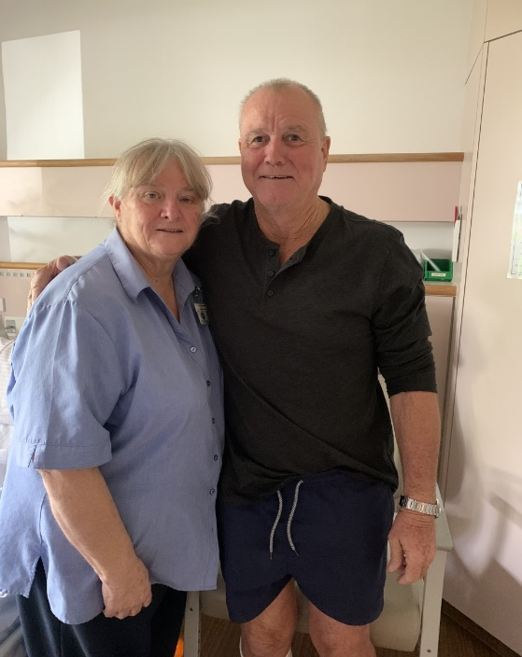

Peter Fox and Andrew Mooney ( Right) Jenny and Mick Corey who is in good hands
after the gym workout in Darwin

GAZZA’S GOSSIP

This month I provide the second part of the statistics about the club in its 110th year which I hope you enjoy.

MAKING HIGH LEVEL ATHLETES: There are 12 known players who have played for South Augusta as juniors and progressed to play within the SANFL. They are Darren Shillabeer (North Adelaide/ Norwood), David Shillabeer (Norwood), Michael Fuller (Woodville), Michael Corey (Woodville), Robert Rozee (South Adelaide), Grant Fuller (South Adelaide), Jared Rivers (North Adelaide), Josh Coulter (North Adelaide), Ron Curyer (South Adelaide), Connor Rozee (North Adelaide) , Brian Bienke ( Port Adelaide) and Harry Kernahan (Glenelg)
South Augusta players who have been drafted into the AFL include Bryan Bienke (Adelaide Crows/ North Melbourne), Jared Rivers (Melbourne), Luke Taylor (Melbourne), Josh Coulter (Adelaide Crows) and most recently Connor Rozee (Port Adelaide).
OFFICIALS: South’s have had 55 A grade coaches since 1912 with Pat Hynes coaching 7 years and Gary Kernahan coaching the most with 8.
South’s have had 36 Presidents in their 110 years, Dave Barry was President for a club record of 15 years and Bruce Curtis was President for a close 9 years. The club has had one female President, Suzanne McKell proudly stepped up during the years 2006 and 2007.
GAME RECORDS
A total of 1,800 players have played either A Grade or B Grade for the club since 1912.
180 players have played over 100 senior games for the club.
25 players have played over 200 senior games.
Only 9 players have played over 300 senior games for the club. Our record holder is Gary Kernahan who has played a whopping 338 games throughout his South Augusta Football Club career.
Since the SGL commenced in 1961, South Augusta and Ports have won 13 Premierships, West Augusta 12, Central Augusta 7, Solomontown 4, and PropRisdon 2.
Five Premierships in a row is a club record and has only been achieved once before in the SGL by West Augusta, from 1972-1976 .
Players who have played in the most A Grade Premierships for the club include:
5 PREMIERSHIPS - Matt Downey, Darcy Kildea, Kahran McKenzie, Caleb Ritter, Craig Shirley , Clayton Milera
4 PREMIERSHIPS - Lionel Brown , Aziel Stuart, Vinny Urbancic , Gary Warren , Jake Collins , Gary Kernahan , Daniel Dohnt, Chris Heron and Greg Shirley
3 PREMIERSHIPS - Kyle Aitken (2018-2020), William Bolitho (2016-2017, 2019), Ronald Fuschtei (2018-2020), Tom Hamilton (2016-2018), Harry Holland (2016-2018), Marcus Kerin (2016-2018), Sam Maule (2016-2018), Billy-Jo Russell (2016-2018), Kriston Thompson (2018-2020), Jarryd Warren (2018-2020), Jaylon Wingfield (2016, 2019-2020), Jarrod Waterworth, Anthony Anno, Chris Heritage, Kevin Harris, Eugene Barry, Harry Burton, Rex McRae, Harry Nicolson, Ryan Struck and Doug Rozee
See you next month , Gazz
Footnote: Congratulations to Gary Kittel who recently turned 80 years of age, we bet that plenty of yarns were told on the party night, well done Gazz.

FOOTBALL FLASHBACK- 1999

This photo comes from the 1999 Under 9s and it’s interesting to see that 3 players are still turning up to play in the A’s and Bs this year , 23 years later. The team also includes several A and B Grade Premiership players and a B Grade Premiership Coach and Coach Andrew Magarey is still heavily involved in the club. If you can guess who the 3 players are who are playing this year , see Harry and if you’re right he will buy you a schooner !

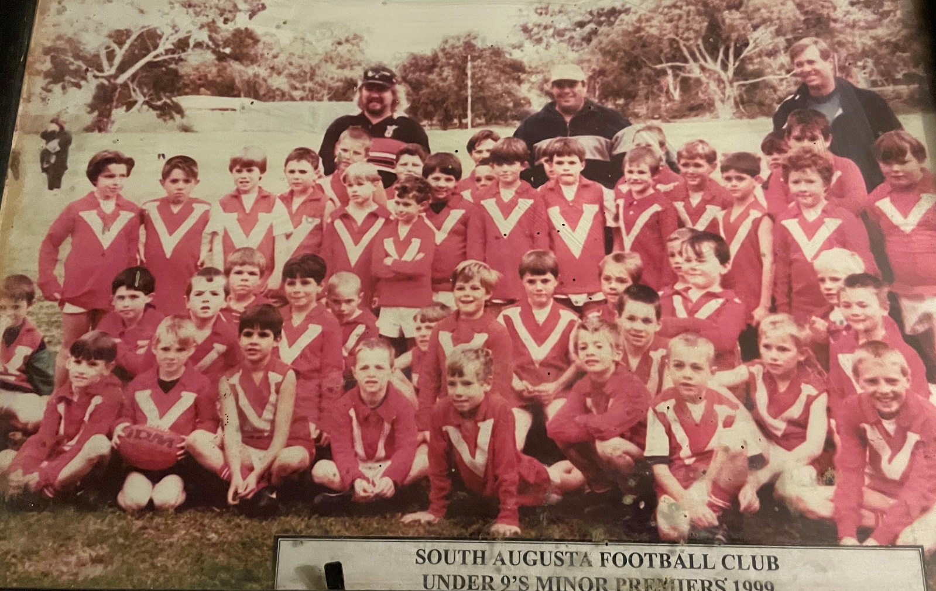

VICE PRESIDENTS AND SPONSORS

Grace I have added the 2 new Sponsors to this list so please update and add Port Adelaide to silver sponsorship thanks

Many thanks to the Vice Presidents who have supported the club financially this year. If you get to the club and don’t know the player you sponsor, please go up and introduce yourself.

PLAYER |  | VICE PRESIDENT/ SPONSOR | VICE PRESIDENT/ SPONSOR
Aitken | Kareem | MARY HIGGINSON | M AND G GROUP
Barnett | Dylan | SHANE & LISA GLASS | PKB ELECTRICAL
Bosence | Cohen | HARRY & VAL WATERWORTH | FLINDERS RANGES USED CARS
Kemp | Terry | ADRIAN & JOY ELLIOT | ROWE PARTNERS
Bunworth | Mitchell | ANDREW & SUE MAGAREY | SUNDROP FARMS
Buzzacott | Darion | ANDREW REYNOLDS | ENDERLINE CONSTRUCTIONS
Clancy | Tom | COLIN WATERWORTH | APM EMPLOYMENT SERVICES
Collins | Jake | GARY KERNAHAN | PASTORAL HOTEL
Collins | Michael | DAVID & JAN GLOEDE | PORT AUGUSTA ISUZU
Cox | Jakeem | DAVID CHAPMAN | SOUTH AUGUSTA RACING TIPS
Dohnt | Daniel | DAVID WINTER | SOUTH AUGUSTA FOOTY TIPS
Fisher | Pat | FLINDERS RANGES CHEAP PRICED CARS | TERRY GARDINER MEATS
Franks | Declan | FRANK MALONEY | PERRY FUEL
French | Mitchell | PORT ADELAIDE FOOTBALL CLUB | BURY PLUMBING
Gade | Ethan | GRAEME COUTTS | FIRE EQUIPMENT MAINTENANCE GROUP
Glass | Paul | JACK WATERWORTH | GUIDOLIN CARPENTRY
Heron | Chris | JEFF SHILLABEER & ROD CHAPMAN | PRESS PLUMBING
Highfold | Elijah | JOHN ORENSHAW | AUGUSTA MOTOR COMPANY
Hoffmann | Lenny | KEAN PARRINGTON | GELDART JEWELLERS
Horner | Stefan | KEITH KELLY | AUGUSTA AUTO MALL
Ikiua | Darren | KYM ELLIOTT | JOHN NOBELIUS
Irvine | Rowan | LORRAINE BOWMAN | SPORTSPOWER
Jones | Brett | MARK & JULIE SHIRLEY | MCDONALDS
Kennedy | Patrick | MATHEW AND SANDY GLAMUZINA | BURSON AUTO PARTS
Kerin | Jak | PETER & SUE TREWARTHA | BARNACLE BILLS
Kildea | Darcy | MICHAEL DIGNAN | HARRYS MAINTENANCE PLUMBING
Magarey | Jack | PHILLIP PIDGEON | D AND G TYRES
McKenzie | Jamahl | PORT AUGUSTA MEAT STORE | DR JONES AND PARTNERS
McKenzie | Kahran | ROBERT BOWMAN | CENTURY 21
McMahon | Rogan | ROGER FRISBY | CROSSROAD CONCEPTS
McMillan | Connor | SOUTH AUGUSTA CRICKET CLUB | SUBWAY
Menzies | Jack | WIL CHRISTIAENS | WEBB SOFTWARE
Milera | Clayton | WILLIAM VIRGO | AUSTRALIAN SPORTS FOUNDATION
Newberry | William | JEFF SHILLABEER JNR AND FAMILY | DALLA SANTA PLUMBING
Parkinson | Cameron | ADRIAN GARDINER | COUTTSIES AUTOS
Parkinson | Clayton | MARY HIGGINSON | AAA AUTO PARTS
Press | Denham | CHRIS HERITAGE | MILHINCH JEWELLERS
Reid | Ethan | JOHN NOBELIUS | CWC SAFETY CONSULTANTS
Brown | Robert | DAVID WILLIAMS | JOHNSTON WITHERS LAWYERS
Ritter | Caleb | CRAIG RITTER | JOHN NOBELIUS
Ritter | Trent | FLINDERS USED CARS | SOUTH AUGUSTA ROUND TABLE
Gade | Dalton | JASON NANCE & JUBA WATERWORTH | BUDGET RENT A CAR
Russell | Billy Jo | SHANE & LISA GLASS | EMMAS DELI
Stuart | Aziel | JOHN NOBELIUS | MAX CRANES
Stuart | Cassius | SCOTT KENNEDY | DOMINOS PIZZA
Stuart | Dominque | VICKI FULLERTON | AUGUSTA CAR WASH
Taylor | Byron | NICK & KAYE FABER | SCHOONERS CLEANING
Thompson | Kriston | GARY KITTEL | AUGUSTA PEST AND WEED
Tiggemann | Cameron | OFFICE NATIONAL | INTERSPORT
Waterworth | Will | PATTY HYNES | HELLO WORLD
Waterworth | Rex | PAUL ELLIOT | CINEMA AUGUSTA
Kemp | Shaun | PETER HUXTABLE | GOTTA BE FISH
Waye | Tyrone | PORT ADELAIDE FOOTBALL CLUB | PAT HYNES
Weir | James | SIMON OWENS | BLUES BROS TEAS
Westwood | Jake | SALTBUSH SURF AND LEISURE | GOTTA BE FISH
Wingfield | Jaylon | SUBWAYS | KFC
Hannes | Eddie | MARY HIGGINSON | PIZZA HUT
Green | Heath | LLOYD AND LORRAINE NELSON | CUP AND CONE

BILLY`S CORNER

In the last few weeks the Advertiser Newspaper has been running articles on the best players from each league and its was good to see some ex South Augusta lads who were mentioned. Darren Shillabeer , 2006 A Grade Premiership player was named in the best 40 players in the Barossa league , currently playing for Barossa District.

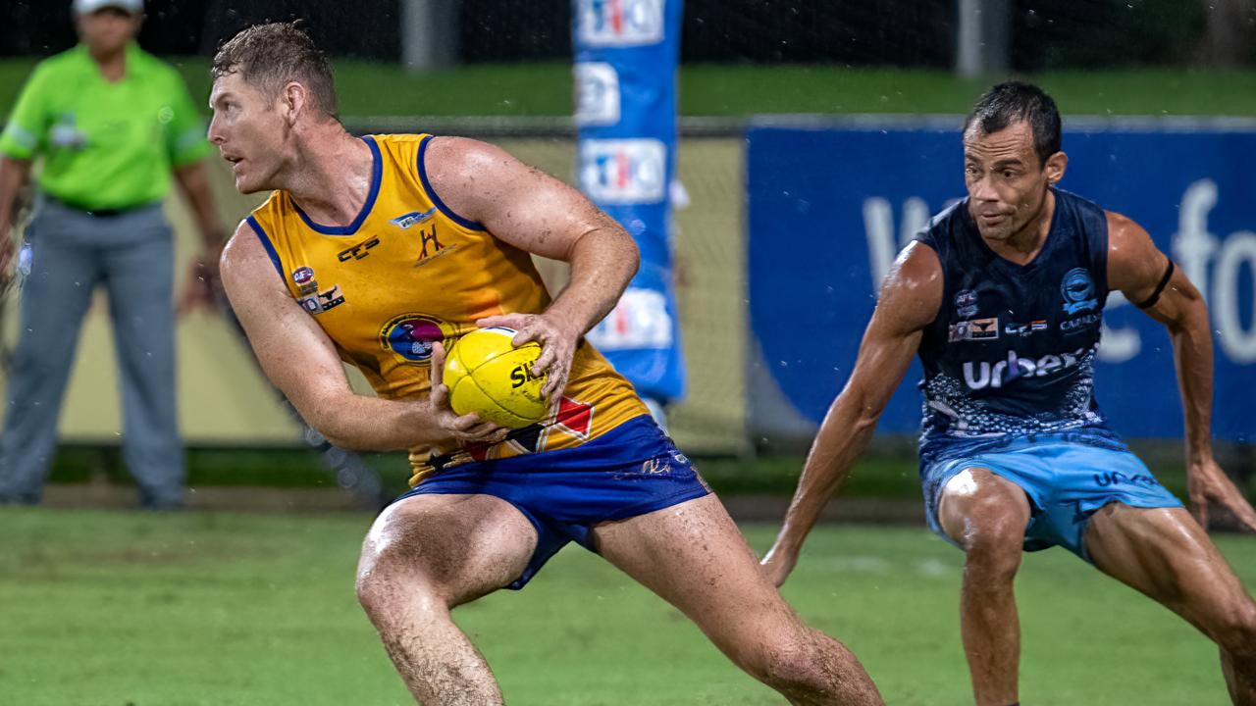
The article commented that Darren Shillabeer remains one of the most dominant forwards in the BL&G. Another Country Championships standout, Shillabeer has been colossal at centre-half forward for the Bulldogs. Shillabeer is fast and decisive with ball in hand and has a booming boot, slotting home 47 goals in 16 games this season and also tallying five best player mentions.

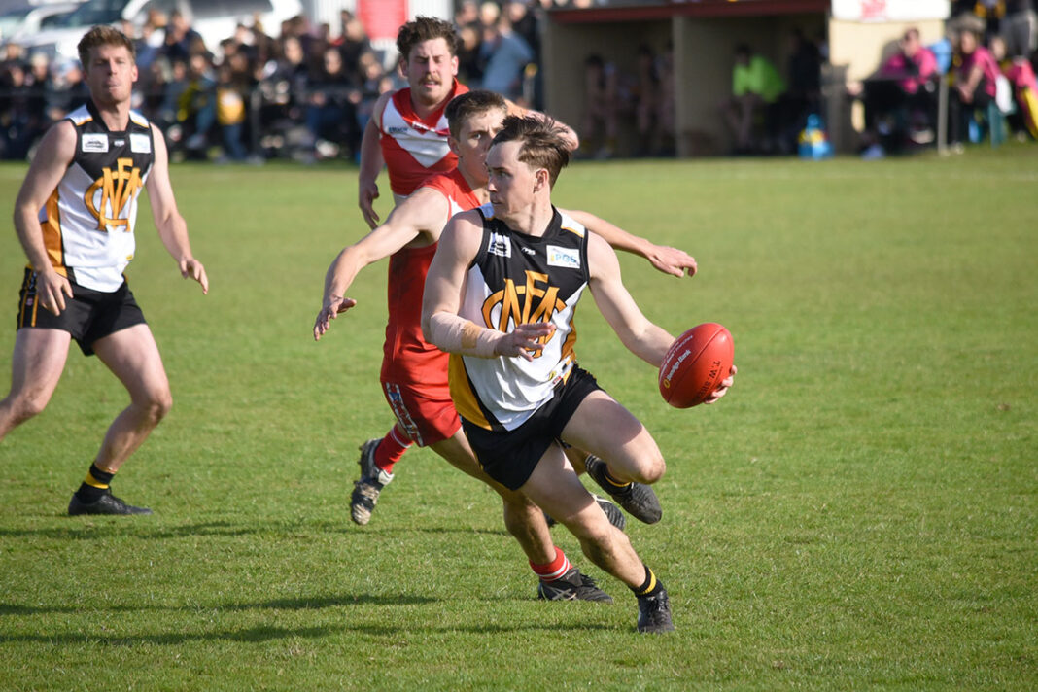

Ex South Augusta Junior player Daniel Noll was named amongst the best players in the South East League playing for Mundulla. The article commented that Daniel has put together a starring year for Mundulla and also represented the KNTFL in its interleague game. An athletic and explosive midfielder, Noll consistently finds space and does damage with disposal by hand or foot. He has kicked seven goals this season and tallied eight mentions among Mundulla’s best in 15 games. Another player to be included in the top players in the South East League was Lawrence Bradley Brown who played in the 2020 SGL Premiership team with South in the Covid year when that league did not play
Players Auction results: A good collect of $400 for Lisa and Shane Glass who won the recent players’ auction . Their team of Aziel Stuart, Paul Glass, Sophie Warren and Katelyn Barnett collected the highest number of votes over the 3-week period with 27 votes. The team also collected $50 each for their efforts.
Second was the team of Cam Tiggeman, Daniel Dohnt, Dylan Barnett and Nicola Sulley Beales with 19 votes and Robert Bowman collecting $160, Caleb Ritter, Jamahl McKenzie, Connor McMillan, Louise Hunter and Jade Grosser with 18 votes and the Trewartha Syndicate getting $80, Fourth was the team of Clayton Milera, Patrick Kennedy, Jaylon Wingfield and Aysha Zada with 17 votes and Kean Parrington collecting $80 and Fifth was the team of Elijah Highfold, Ethan Gade, Eddie Hannes and Ellie Packard with 15 votes and the Trewartha Syndicate collecting $80. Many thanks to those who participated in the auction with $1,000 going towards the Football Operations costs.

Sad news to hear the passing of Adrian Hull who was a past junior player for South Augusta and a member of the 1970 Under 18s Premiership side. Adrian actually played most of the season in the Under 15s and was brought in for the Grand Final after winning the Under 15s medal that year. Adrian was brought into the team by South Coach Graham Pidgeon to curb the influence of his brother Joey Hull who was playing for Willsden and had won the Under 18s League medal. Adrian did a great job apparently and South defeated Willsden who had hardly lost a game all year. Adrian didn’t go on with his football and play senior football at Souths. The club offers its condolences to brother Joey and Adrian’s friends and family at this sad time.

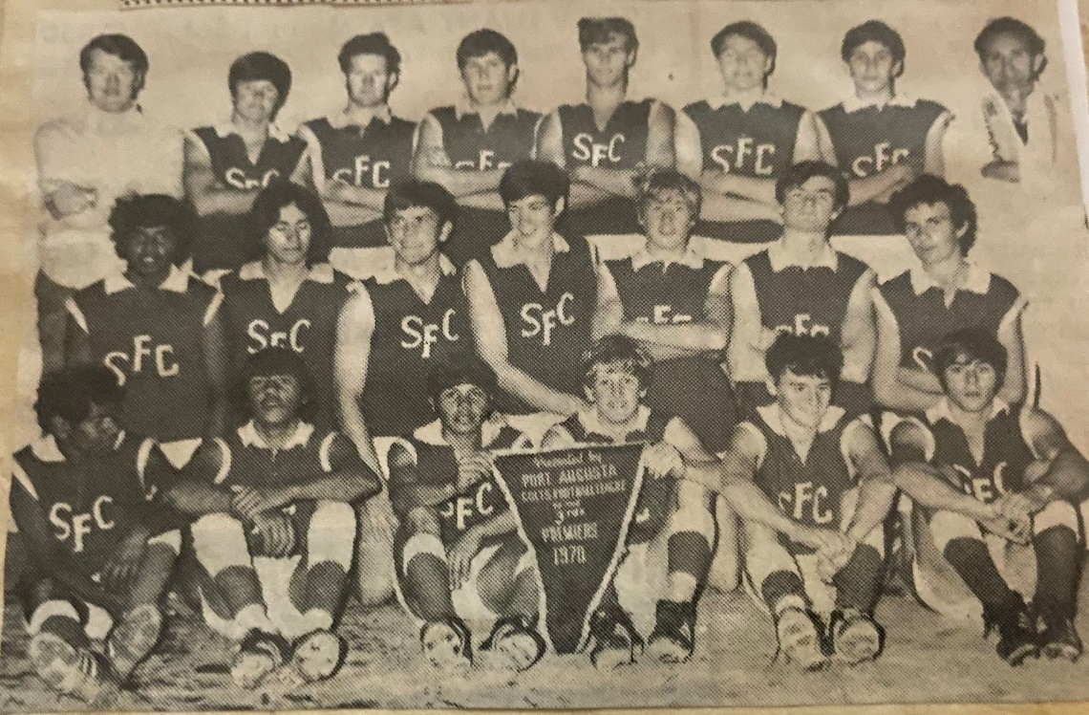

1970s Under 18s Premiership team, Adrian is pictured in the team on the bottom row on the far left of the Premiership picture.

Jed Anderson, grandson of South Augusta 1964 A Grade Premiership player Jimmy Anderson has been delisted from North Melbourne after playing 99 AFL games for both Hawthorn and the Kangaroos. We wish him the best in the future and hopefully he will be picked up again by another club.

Ex South Junior Isaac Keeler was in town recently after his team North Adelaide had a bye in the finals. Isaac works at Terry Howe Printing and is doing an apprenticeship. Souths are investigating the costs of updating the history books for the last 10 years and we noticed him there and introduced ourself. We wish him luck with opportunities in the draft and you never know he may be in the next book!

Ryan Struck recently played his 400th senior SGL game which is a fabulous achievement with his time at Souths including 3 A Grade Premierships. Ryan first came to South as an Under 11 and played his first Game against West as a 16-year-old in 1997, playing in the 2000 A Grade Premiership side before moving to Quorn Wolves. In 2006 he returned to South and played in another Premiership that year, winning the club Fairest and Best in 2007 and tied for the Madigan Medal in 2010. In 2012 he was part of another A Grade Premiership and member of the 2015 B Grade Premiership team and won the clubs best team man on 4 occasions. He was made a South Life member in 2012 and played 7 matches for SGL and the Northern Zone , playing a total of 222 League games and 20 seconds games for the South Augusta club and with the other clubs League and Seconds games together with SGL and Zone he has played 400 games. Congratulations on a great career Ryan and all the best for the future.

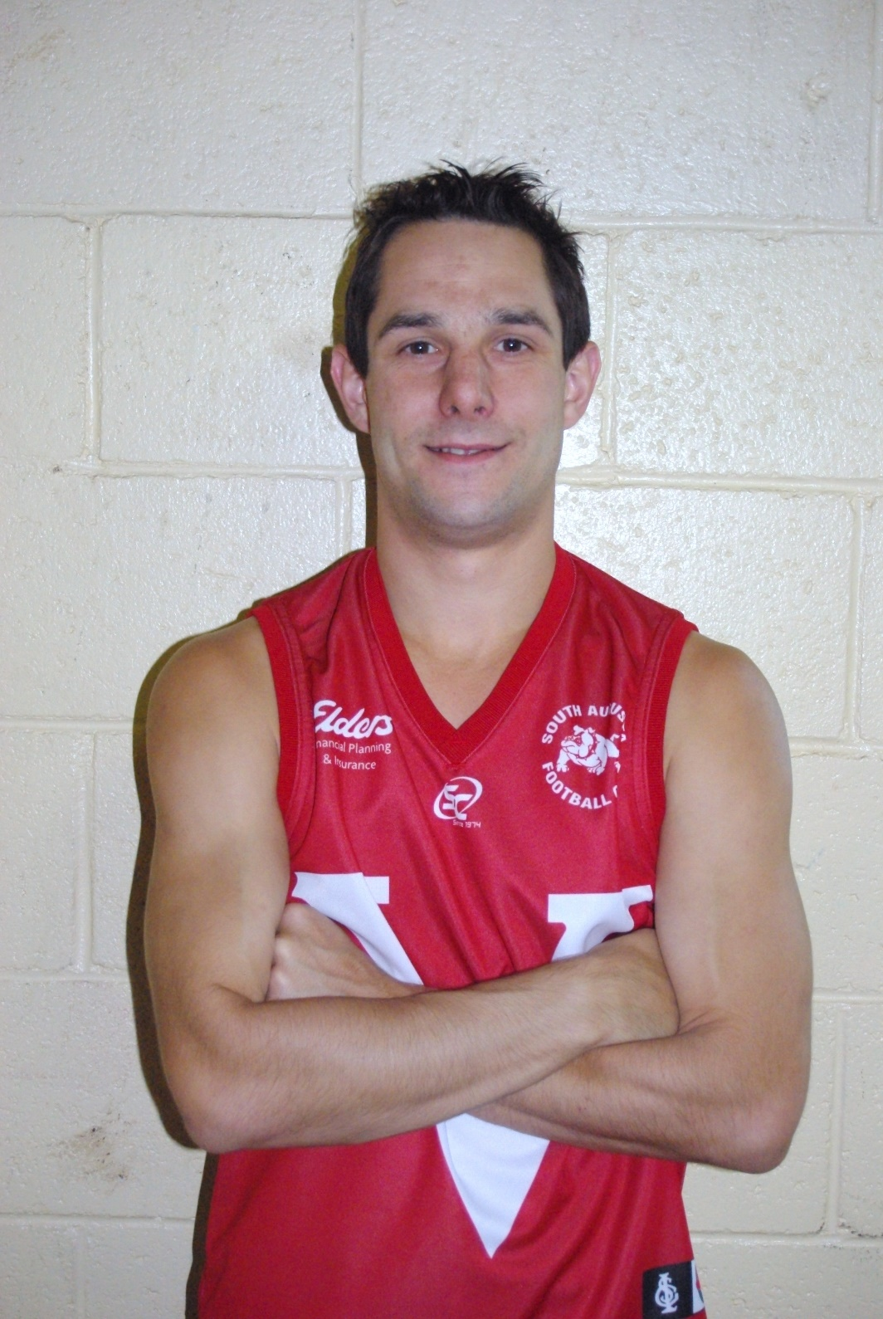

The President received a donation from a lady connected to Ivor Nicholls, who died in 1985 but passed on to her some badges she thought the club might be interested in. The picture below (Left to right) has a badge for the Port Augusta Football League, 1956 South Augusta, SGL Medal for Officials and a 1939 South Augusta badge which is the year we won the Premiership and the 4th for the club. They will be stored with the history folders which come out at reunions etc.
